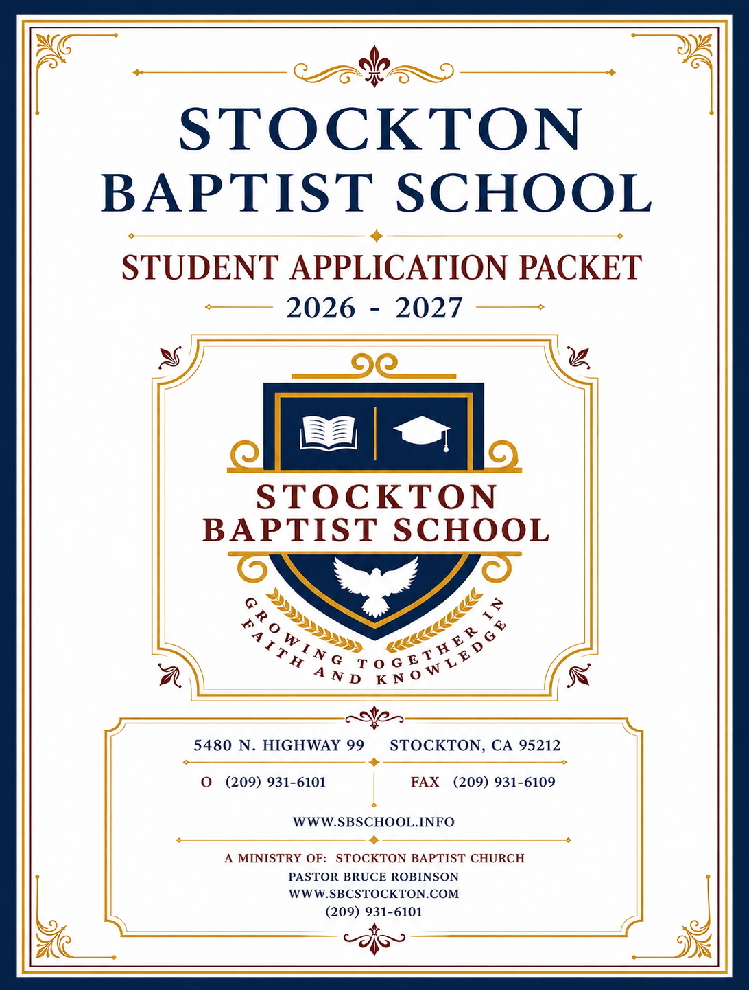

Tuition Fee Schedule for the 2026-2027 School Year
YEARLY 10 MONTH *12 MONTHS (June-May)

KINDERGARTEN-EIGHTH GRADE (8:15am-3:00pm)
FIRST STUDENT $5,250.00 $535.00 $445.00
SECOND STUDENT + $4,350.00 $445.00 $370.00
NINTH-TWELFTH GRADE (8AM-3:00PM)
FIRST STUDENT $5,300.00 $540.00 $450.00
SECOND STUDENT + $4,650.00 $475.00 $395.00
Tuition Referral Program: For each enrolled student that you refer, you will receive: $50.00 off your tuition each month they are enrolled.

Payment dates: You may choose one of the following options: 1st of each month or the 15th of each month or split your payment on the 1st & the 15th of each month.
A late fee of $30.00 will be assessed after the 5th or the 20th of the month.

Extended School Day: Monday through Friday 3:15-4:00 - Students needing help with their schoolwork may stay and be given homework help during this time.
After School Care: $200.00 per month. After School Care runs from 3:30-4:30pm (M-F) Students must be picked up by 4:30pm unless special arrangements have been made.

Non-Refundable Books and Registration Fees:
Book Fee: K-12th Grade: $450.00 This must be paid in advance before books can be ordered. If possible, the books will be reused to lower the cost. You are responsible for the cost of replacing lost or damaged books.
Registration Fee: After 4/30/2026 $150.00
Registration Discounts - If paid before 3/31- $100.00; before 4/30/-$125.00
This is an annual fee and is due at the time of registration for the student and is non-refundable. Only upon payment of this fee is your child’s space reserved.

Annual Iowa Testing Fee: $30.00 - This is for 1st-12th grade students.

Early Withdrawal
If you choose to withdraw your student from SBS, you must submit a 30-day written notice to the school office. Fees:
- $400 withdrawal fee, plus:
- ½ month’s tuition if notice is given before the 16th of the month prior to withdrawal, or
- Full month’s tuition if notice is given on or after the 16th of the month prior to withdrawal

Student records or transcript requests will require a 2-week processing time.
Any amount that is due to be returned to the parents after all fees have been assessed will be given in equal increments determined by the school, beginning within 90 days from the last day of attendance.

Families are required to participate in fundraisers. Families wishing to not participate in fundraisers throughout the year will be allowed to exempt themselves at a charge of $150.00. Payment of this fee can be split into two payments of $75.00 each on your October and April payments. PLEASE COMPLETE THE FUNDRAISER EXEMPTION REQUEST FORM.

Stockton Baptist School accepts all major credit and debit card payments. In addition, payments may be made through our website at www.sbschool.info.



Stockton Baptist School 2026-2027
Noah’s Ark Preschool

Family Contact Information Please fill in completely and sign
Student Name: ___________________________________________ Grade: ____________ DOB: _________________
Payer’s Name: Mr. Mrs. Ms. _______________________________________________________________________________
Payer’s Date of Birth: ____________________ Payer Telephone: ________________________ / _______________________
Secondary Contact: Mr. Mrs. Ms. ____________________________________________________________________________
Payer’s Street Address: ____________________________________________________Apt: ________
City: _____________________________ ST:___________ Zip: ________________ SSN#: ____________________________
Email: _________________________________________________________________________________________________

1

Circle one
First Middle Last

Circle one
First Middle Last

Plan Options

A $30 late fee will be charged to each account if past the 5th or the 20th.
Due on the 1st & 15th
Due on the 15th
Due on the 1st
2

10 Installments: 12 Installments: Other:____________________
Due 8/1/2026 to 5/1/2027 Due 8/1/2026 to 7/1/2027 Dates: ______________________

10 Installments: 12 Installments: Other: ____________________
Due 8/1/2026 to 5/1/2027 Due 6/1/2026 to 5/1/2027 Dates: ________________________

20 Installments:
Due the 1st and 15th of each month
from 8/1/2026 to 5/15/2027

Pay tuition in full: $0

Registration & Books $ ______________________ Amount due
$ ______________________ date paid ____________ $ ___________________ date paid _________
BOOKS can only be ordered when paid for.
To qualify for early registration discount, payments must be made on time.
Books & Registration is non-refundable.

3

Administrator Signature Date
1. Tuition $____________________
2. -Scholarships $____________________
3. =Total Plan Amount $____________________
4. divide 9,10,12 or 20 _________
5. = Installment Amount $______________
_________________________________________________
SCHOOL USE ONLY
Notes:

Signature required

2026-2027 Stockton Baptist School Student Information Form

1st Child’s Name: ________________________________________________________________________________________________
(Last) (First) (Middle Initial)

Address: ______________________________________________________________________________________________________
(Street) (City) (ZIP)

Grade: ___________ Age: _______ Date of Birth: ________________________________ Phone: _____________________________

Right or Left Handed (circle one) Student's grades have been: ( ) Superior ( ) Above Average ( ) Average ( ) Below Average

Physical Difficulties: ____________________________________________________________________________________________
Food or Drug Allergies: __________________________________________________________________________________________
Previous School: _______________________________________________________________________________________________

2nd Child’s Name: ________________________________________________________________________________________________
(Last) (First) (Middle Initial)

Address: ______________________________________________________________________________________________________
(Street) (City) (ZIP)

Grade: ___________ Age: _______ Date of Birth: ________________________________ Phone: _____________________________

Right or Left Handed (circle one) Student's grades have been: ( ) Superior ( ) Above Average ( ) Average ( ) Below Average

Physical Difficulties: ____________________________________________________________________________________________
Food or Drug Allergies: __________________________________________________________________________________________
Previous School: _______________________________________________________________________________________________

3rd Child’s Name: ________________________________________________________________________________________________
(Last) (First) (Middle Initial)

Address: ______________________________________________________________________________________________________
(Street) (City) (ZIP)

Grade: ___________ Age: _______ Date of Birth: ________________________________ Phone: _____________________________

Right or Left Handed (circle one) Student's grades have been: ( ) Superior ( ) Above Average ( ) Average ( ) Below Average

Physical Difficulties: ____________________________________________________________________________________________
Food or Drug Allergies: __________________________________________________________________________________________
Previous School: _______________________________________________________________________________________________

4th Child’s Name: ________________________________________________________________________________________________
(Last) (First) (Middle Initial)

Address: ______________________________________________________________________________________________________
(Street) (City) (ZIP)

Grade: ___________ Age: _______ Date of Birth: ________________________________ Phone: _____________________________

Right or Left Handed (circle one) Student's grades have been: ( ) Superior ( ) Above Average ( ) Average ( ) Below Average

Physical Difficulties: ____________________________________________________________________________________________
Food or Drug Allergies: __________________________________________________________________________________________
Previous School: _______________________________________________________________________________________________

Church Information

Church now attending: ____________________________________________________ Pastor’s Name: _________________________

Address: _______________________________________________________________ Phone Number: _________________________

Parent Information

Father’s Name: ______________________________________ Home Phone: _________________ Cell Phone: __________________

Address: ___________________________________________ City:_________________________ State: _____ Zip: _____________
E-mail address: ________________________________________________________________________________________________

Occupation: ___________________________________________________________________ Work Phone:
Company Name: ____________________________________ Company Address: _________________________________________

Mother’s Name: ______________________________________ Home Phone: _________________ Cell Phone: __________________

Address: ___________________________________________ City:_________________________ State: _____ Zip: _____________
E-mail address: ________________________________________________________________________________________________

Occupation: ____________________________________________________________________ Work Phone: _________
Company Name: ____________________________________ Company Address: ___________________________________________

With whom does the student reside?________________________________________________________________________________

Two Emergency Phone Numbers – to be contacted when parents cannot be reached:
1. Name Phone # Relationship to student
2. Name Phone # Relationship to student

Child Pick-Up Authorization
The following people have permission to pick up my child:
Name | Phone Number | Relationship to child

Parent's Signature: _____________________________________________________________________________Date______________

Parent Understanding and Commitment is Required for Admission:

“We the parents or guardians of _____________________________________ do hereby request enrollment in Stockton Baptist School for our child. We know that the Bible places primary responsibility on the home for education, especially on the father, and we request this school to assist us in meeting this responsibility. It is our conviction that our child must have an academic education based on the Word of God and its teachings. We hereby certify that we request this school to operate on our behalf with the following understanding:

1. I understand that it is an effort of this school to meet the needs of the families of the church and community to train up our children in the way that God would have them go, and that the Bible teaching will be reflected in all affairs and teachings of the school.
2. I understand that it is expected of our family that we will maintain a family and church life that is consistent with the teachings of the Word of God. This should include regular prayer and Bible reading, church attendance, and loyal support for the school ministry.
3. I realize that from time-to-time children take issue with actions that they do not agree with and that they are prone to criticize statements out of context. This being normal for children, I pledge that should such a occur, I will not support the criticism; that I will correct my child, support the school personnel, and call the school for full details at any time I have a question concerning an incident.
4. I further realize that building strong relations with my child’s teacher to aid in the training of my child is as much my responsibility as it is the school’s, and that I must pray for the staff and program, cooperate with them in discipline, be accepting of their judgment in such matters, lay a spiritual foundation through Godly example in the home, support the spiritual training of chapel, revivals, etc., follow through with any work assignments or slips to be signed, see that the child starts school on time, keep written excuses for absence or tardiness, cooperate in training the child to respect school property and pay for irregular abuse of same, attend all parent functions and assist in publicizing the school.
5. I understand that parents or students who are not in harmony with the school standards or programs will be asked to submit to the program; if they will not, the parents will be asked to withdraw their child.
6. I realize that attending Stockton Baptist School is a privilege and not a right; and it is my intention to abide by the decisions and to support the discipline of the administration.

I have read and understood the information materials furnished as well as the school handbook and agree to insist that my child submit to the programs academic and disciplinary regulations and all other requirements instituted by the administration and carried out by the faculty.

______________________________________ ___________________________
Father’s Signature Date
______________________________________ ___________________________
Mother’s Signature Date

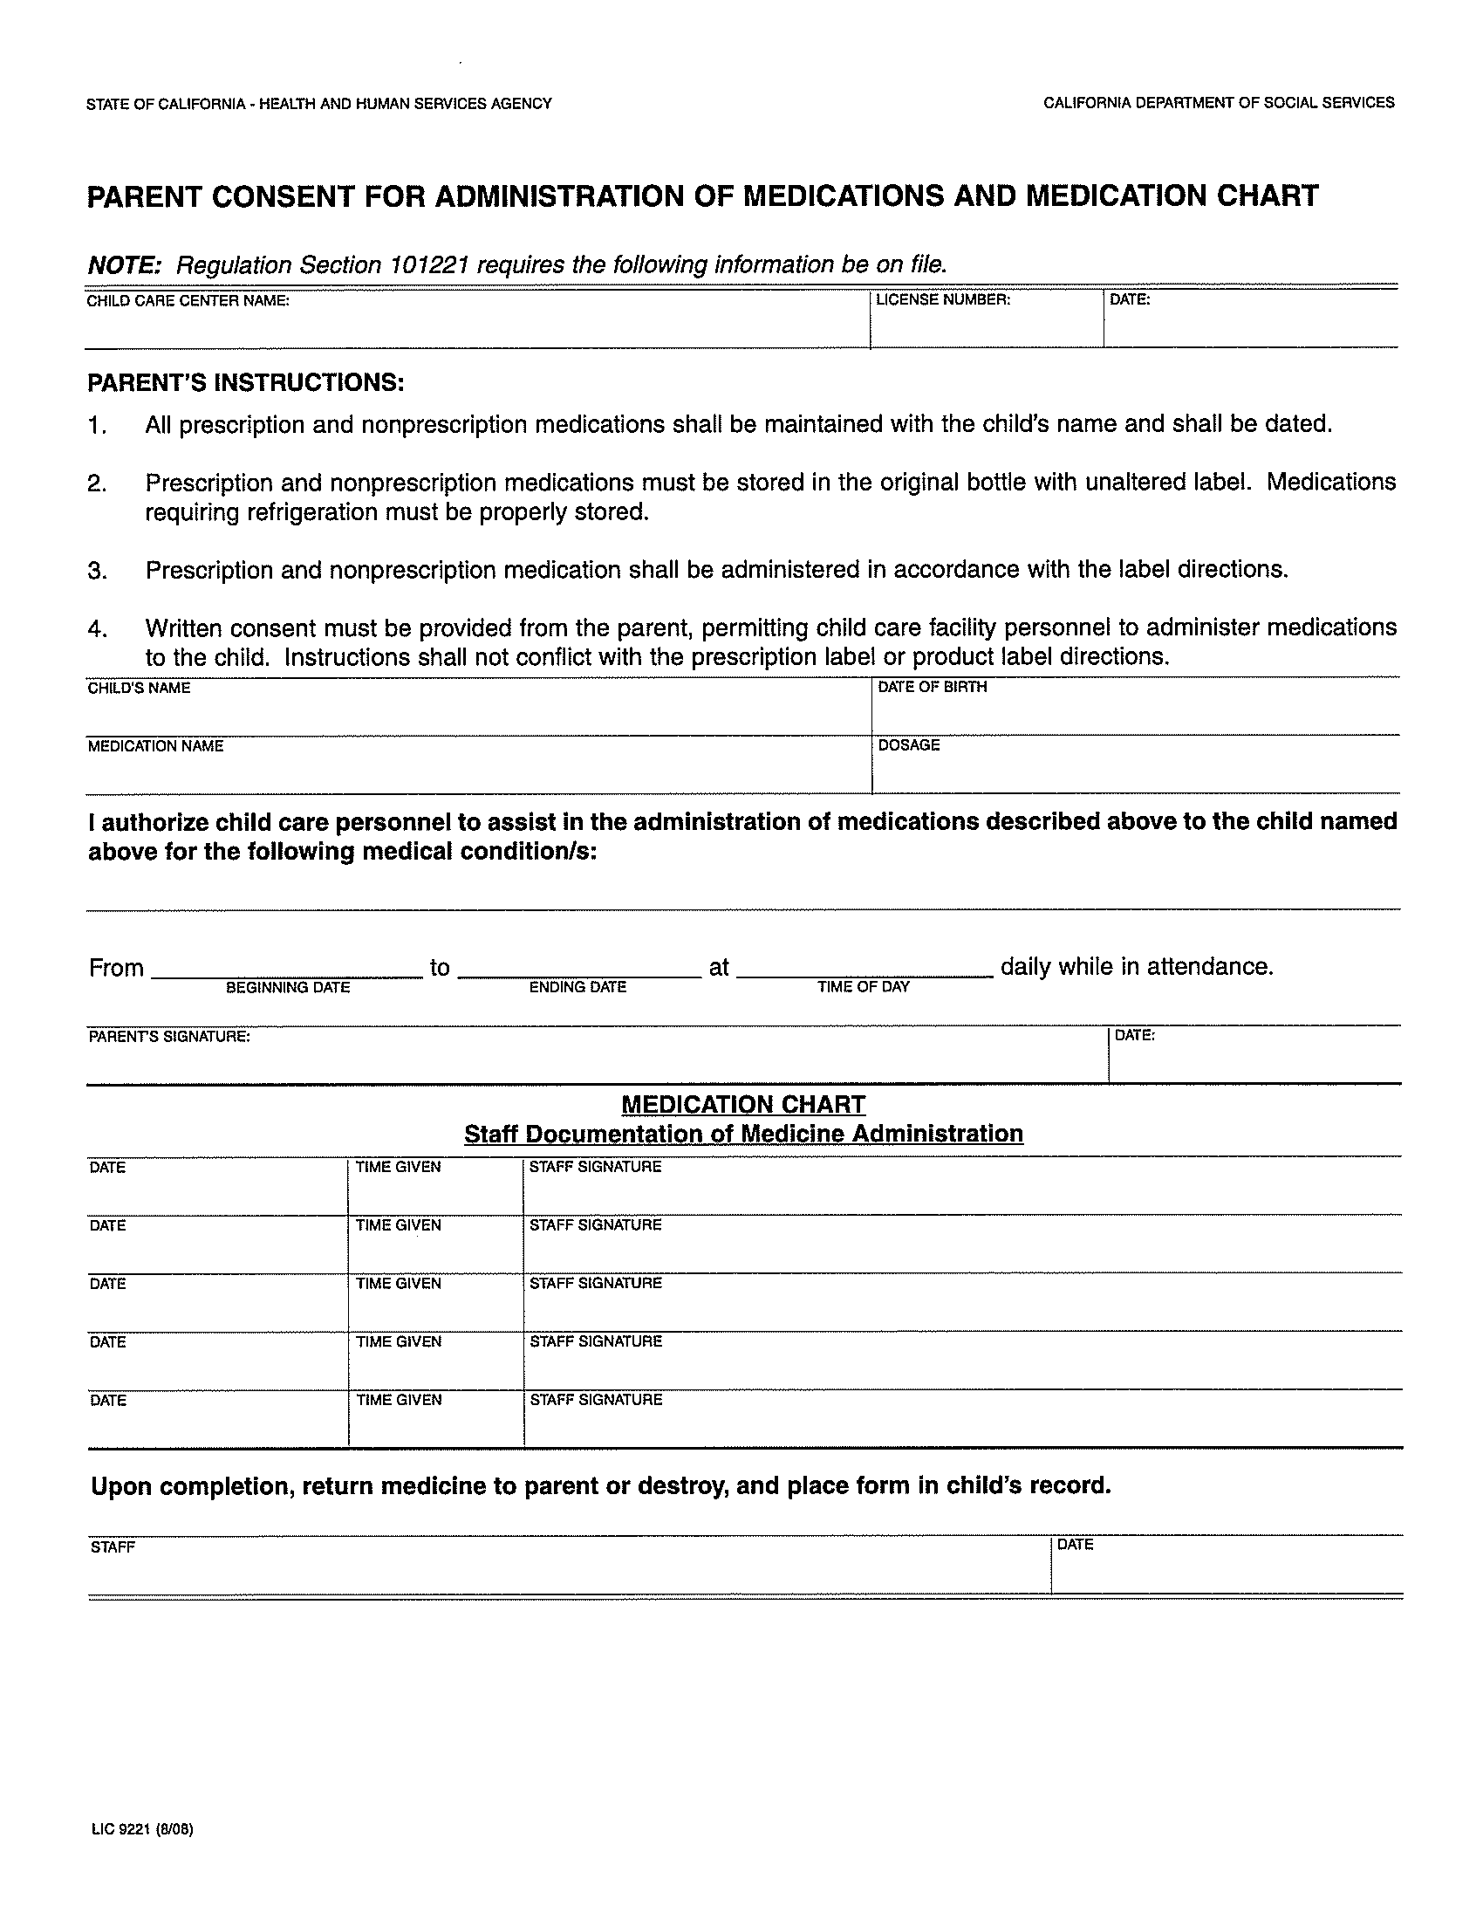
I give Stockton Baptist School permission to administer as needed:
_____ OTC Pain Reliever
_____ Cough Drops
_____ Stomach Reliever (Pepto Bismol)

Signature: ______________________________________________

Photo/Media Permission

To best promote our school, we would like to ask permission to photograph/record your child to use in any of our publications. Please sign below to give your permission.
Thank you,
Stockton Baptist School Staff

I, __________________________ give Stockton Baptist School permission to photograph/record my child(ren).

I, __________________________ do not give Stockton Baptist School permission to photograph/record my child(ren).

Child(ren) Name(s): _______________________________________________

__________________________________________________________________

_______________________________ _________________________
Parent Signature Date

Stockton Baptist School & Stockton Baptist Preschool Academy
Fundraiser Agreement

Student Name: ___________________________

To help provide the students at Stockton Baptist School and Stockton Baptist Preschool Academy with safe, well-maintained buildings, playgrounds,
and facilities, occasional fundraisers are held throughout the year.

Please sign below to acknowledge that you have read and understand this policy.

___________________________________ ____________________
Signature Date

We understand that participating in fundraisers may not be convenient for every
family. As outlined in our school handbooks, families may choose to opt out
of all fundraising efforts by paying a $150 fee per student for the school year.

You may choose to:
- Pay the full $150 in October, or
- Split the payment into two $75 charges—one in October and one in April

Please complete one form per child if requesting exemption.
Please check one option:
⬜ Charge $150 in October
⬜ Charge $75 in October and $75 in April

I, _______________________________________, request to be exempt from all fundraisers for the 2026–2027 school year for my child.
I agree to the above-marked fee(s) to be applied to my child’s tuition payment(s).
Child’s Name: _____________________________________________
Parent/Guardian Signature: _________________________________
Date: ___________________

Stockton Baptist School

Parents: Please read the following statement carefully and sign below to indicate your agreement.

I hereby affirm that I have read the Student Handbook and discussed its policies with my student.
I certify that I consent to and will submit to all governing policies of the school, including all applicable policies in the Student Handbook.

I understand that the standards of the school do not tolerate profanity, fighting, obscenity in word or action, dishonor to the Holy Trinity and the Word of God, disrespect to the personnel of the school or any students, or continued disobedience to the established policies of the school.

I understand that the services of the school are engaged by mutual consent, and that either the school or I reserve the right to terminate any or all services at any time. I understand that this Handbook does not contractually bind Stockton Baptist School and is subject to change without notice by decision of Stockton Baptist School’s governing body. Admission to the school is a privilege, not a right, and admission for one school year does not guarantee automatic admission for future school years.

______________________________________ _________________________
Signature of Mother Date

________________________________________________ ________________________________
Signature of Father Date

Students in Grades 5-12: Please read the following statement carefully and sign below to indicate your agreement.

I hereby affirm that I have read the Student Handbook. I certify that I consent to and will submit to all governing policies of the school, including all applicable policies in the Student Handbook.

I understand that this Handbook does not contractually bind Stockton Baptist School and is subject to change without notice by decision of Stockton Baptist School’s governing body.

I understand that admission to the school is a privilege, not a right, and that any behavior, either on or off campus, which is not consistent with the school’s standards could result in the loss of that privilege.

__________________________________
Signature of Student Date

Field Trip Permission Form–2026-2027
Please Print

Student Name:________________________________________________________________

Home Phone:_________________________________________________________________

Address:_____________________________________________________________________

City, Zip:____________________________________________________________________

Parent/Guardian name:_________________________________________________________

I hereby give permission for my child to participate in the following:
All field trips with Stockton Baptist School

I, _______________________________, give my permission for my student to travel with the school program to and from field trips. As a parent or guardian, I hereby give my consent for the responsible leader to authorize necessary hospitalization or treatment, including injections, anesthesia, surgery, and medication, should an accident or other medical emergency occur during a trip or activity and the responsible leader is unable to reach me.
As parent or guardian, I also agree to be responsible for all debts not covered by Stockton Baptist School that are incurred by the student during the trip or activity, for all expenses not covered by insurance that are incurred as a result of any accident, illness, or medical emergency involving the student, and for all transportation costs to prematurely return the student to Stockton, CA, should the student’s continued participation jeopardize the safety or health of the other participants.

I understand and agree that I may be required to pick up my student from the field trip if behavior issues or sickness occurs.

Parent/Guardian Signature: ____________________________________Date: ______________

Medical #_______________________________________

Dr. Name_______________________________________

Known Allergies__________________________________

Stockton Baptist School Student Standard of Conduct (5th-12th Grade)

Student’s Name _________________________________________________Age ___________
Last First Middle
The student’s attitudes, conversation, and behavior reflect the character of the institution from which he derives his training, both home and church. This form reflects the Christian school’s attempts to secure students who would best adjust to the rigor of a highly disciplined training program that must set high standards. These standards will result in a characterized student leading in reformation for our nation and the world.
Do you attend church regularly? _____ Yes _____ No
Where? __________________________________________________________________________________
Are you a Christian? _____ Yes _____ No At what age did you receive Christ as your Savior? ____________
Do you accept the Bible as God’s Word and submit yourself to its principles as a final authority in every area of your life? _____ Yes _____ No
Do you sincerely pledge allegiance to the Christian and national flags? _____ Yes _____ No
Have you ever smoked_____ Yes _____ No Have you ever drank alcohol? _____ Yes _____ No
Have you ever used or possessed narcotics (pills, marijuana, etc.) of any kind? _____ Yes _____ No
Have you ever run away from home? _____ Yes _____ No If yes, how long ago? ________________
Will you promise not to draw, wear, or display in any way anti-Christian symbols? _____ Yes _____ No
Will you agree to dress according to the uniform guidelines and hair code? _____ Yes _____ No Will you agree to dress in public in a manner that will be a consistent, daily example of our Lord Jesus Christ?
_____ Yes _____ No
Will you honestly agree to keep all the school rules and respect authority without being critical and finding fault?
_____ Yes _____ No
General Policy:
Students are expected to abide by these standards of conduct throughout their enrollment whether at home, church, or elsewhere. Students found to be out of harmony with the school’s ideals of work and life may be invited to withdraw if the administration determines it is necessary.
As a student at the Christian school, I pledge to uphold this school’s standards against cheating, fighting, swearing, smoking, gambling, dancing, drinking alcohol, using or talking favorably about narcotics, or using indecent language, and will act in a very orderly and respectful manner. I will maintain Christian standards in courtesy, kindness, morality, and honesty. I will strive to be of unquestionable character in dress, conduct, and other areas of life.
I agree to abide by the above standards of conduct and other regulations expected of each student enrolled in this Christian education program while I am a student attending the school and will not give the impression to students, parents, or faculty that I am not in harmony with the goals, aims and standards of the school.

_______________________________________ _________________________
Student’s Signature Date

_______________________________________ __________________________
Parent’s Signature Principal’s Signature

Pastoral Recommendation (5th-12th Grade)
Dear Pastor,
The following student is applying for admission to Stockton Baptist School. Please complete and return the following information as soon as possible. We must have this information to complete the processing of the application. All information will be kept confidential. Thank you for your assistance.

Student’s Name: _____________________________________ Grade: ______________

How long have you known the student: ________________________

In what church activities does the student participate? __________________________________

How would you rate the student in these areas:

 | Superior | Above Average | Average | Below Average | Comments
Personal Integrity
Leadership
Self-Control
Respect for Authority

How many services does the family attend per week? ____________________________________

What do you consider the students strong points? _______________________________________

What do you consider the students weak points? ________________________________________

Does the applicant have special skills or talents? _________________________________________

Additional Comments: ______________________________________________________________
_________________________________________________________________________________
_________________________________________________________________________________

Pastor’s Name: ________________________ Name of Church: _____________________________

Signature: ___________________________________________ Date: _______________________

Please mail/email to: Stockton Baptist School, 5480 N. Hwy 99, Stockton, CA 95212, (209) 931-6101
Or Fax to: Stockton Baptist School Attn: School Office (209) 931-6109. info@sbcstockton.com

